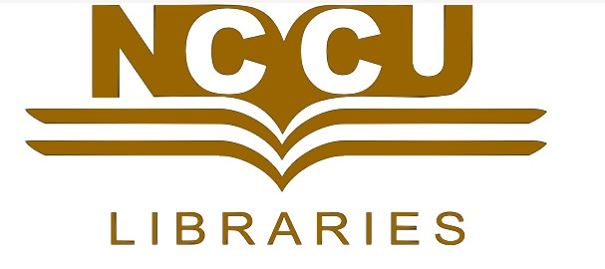
贈書意願表
書 況 確 認 | □全新 □八成新  遇以下情況：□破損□套書但不完整□註記或眉批  □影印本等 請帶回(歸還贈書者)，謝謝！
對贈書之後續處理 | 贈書者同意對贈書來源之合法性擔負全部責任(例：他處借閱之圖書，不得贈與本館，須自行歸還原歸屬人/單位)，且贈書交由圖書館全權處理，不過問後續處理。  簽名__________________________
贈 書 冊 數 | 書名：  共計 _______種_______冊
贈 書 原 因 | □本人著作  □校友饋贈 □家中書籍過多  □畢業生完成學業，相關研究書籍捐贈  □其他__________________________
資 料 內 容 確 認 | □主題：  □特殊說明：
謝 函 | □需要，請寄至：  □不需要
登載 芳名錄 | □願意□不願意
印贈書者姓名於書名頁 | □願意□不願意
贈書者聯絡資訊 | 姓名：_____________  服務/就讀單位：_____________  身份：□在校生□校友□本校教師□教職員(退休)□其他_____________  聯絡方式：手機/家電話___________________  電子信箱______________________  (請務必留下正確資訊，以便能聯絡重要訊息)  (贈送日期：西元 年 月 日)
非常感謝您的贈與！！敬祝 美好的一天～
Willingness to Donate Books

Check the book's condition | □Like new  These are to be rejected and returned to the donor: □damaged □ incomplete book set □has hand-written notes or remarks □ photocopies.
Books that are not yet collected by the Library are processed otherwise. | Agree to let the Library take over, but will not ask about the follow-up procedures.  Signature_______________________
Number of books donated | Name of Book:  Total ______types______ volumes
Reason for donation | □ Donor's work  □ Donor has completed studies and wishes to donate relevant books.  □ Donation from an alumnus  □ Too many books at home  □ Other _________________
Confirm the content | □ Topic:  □ Special description:
Letter of Appreciation | □ Required. Please mail it to:  □ Not required.
Does the donor wish to have his/her name be known? | □ Yes □ No
Does the donor wish to have his/her name printed on the title page? | □ Yes □ No
Donor's contact information    Thanks for your donation! Have a nice day~ | Name:_____________  Work/School:_____________  Identity:□ NCCU student □ Alumnus □ NCCU teacher □ Staff (retiree) □ Other________  TEL: Mobile/Home__________________  E-mail:  (please leave correct information for future contact)  Date of donation:

